**Our Cluster Religious Ed.**

**Program**

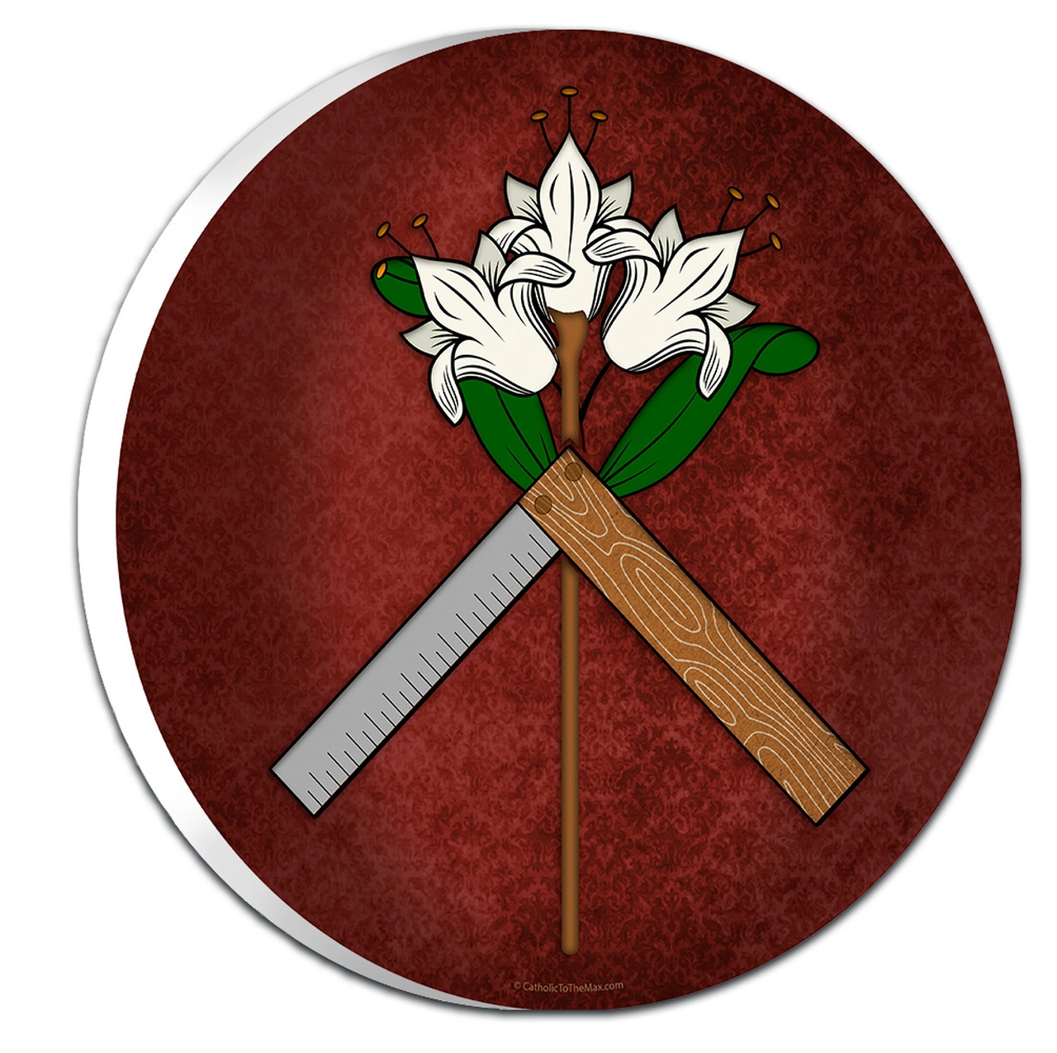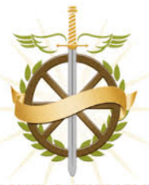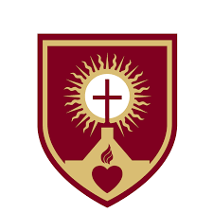

**St. Catherine’s, St. Francis Xavier’s, &**

**St. Joseph’s Parish**

**Community**

**Overview**

We recognize that parents are the primary educators in the Faith of their children. John Paul the Great once said, “The family is the domestic church.” This means that our homes are meant to be holy, sacred places where our children can grow and flourish. The home is where children learn to pray, forgive, and love one another. Our main goal as parents is to help get our children to Heaven. Therefore, we, as catechists, are here to assist you, the parent in the formation of your child.

**Curriculum**

*Catechesis of the Good Shepherd* ~ grades K/1st

The Catechesis of the Good Shepherd is a program of Christian formation for children ages 3 through 12. It begins with the understanding that there is a deep bond between God and each child. CGS is based primarily on the teaching style of Maria Montessori. This is a very hands-on approach to the Gospel. After hearing God’s word proclaimed, children are free to work with materials that represent the essence of the Christian message. The Atrium is the spiritual environment that is specially prepared for students. It’s a prayerful place where students encounter God through prayer and contemplation. It is our hope that through these visits to the Atrium, children will begin to fall in love with God and understand the importance of prayer, scripture, and sacred liturgy.

*Renewed/Received ~Ascension Press* - 2nd Grade

This program is the primary source that students will be using for their sacramental preparation. The book comes alive for students within the personal story of a young girl who is actively living out the Catholic faith within her family and church setting. The first semester will focus on preparation for the Sacrament of Reconciliation, which students will receive in December. The second part focuses on preparing to receive Jesus in the Holy Eucharist. Each chapter coincides with an episode that students watch in class.

*Word of Life* ~ 3rd-6th Grade

This curriculum is used for students who are in between their sacramental years. Word of Life features a unique spiral scope and sequence based on seven essential doctrinal themes. Age-appropriate content for each theme is presented at every grade level as the child grows and develops.

3rd - Holy Spirit & the Life of Grace

4th - The Creed: Truth and Our Response of Faith

5th- Liturgy & Worship

6th -The Word of God: Jesus Christ & Sacred Scripture

*Decision Point* ~ 7th Grade

In his unique style, Matthew Kelly invites students to delve into their Catholic faith through a personalized, journal-style approach to discovering a relationship with Christ. This curriculum is focused on getting students to recognize the Holy Spirit at work in their lives as they prepare to receive His gifts which will be poured out on them in Confirmation. It challenges students to courageously take up their mission to become mature, passionate followers of Christ and His Church.

*Chosen* ~ 8th Grade

This program is uniquely designed to prepare students for Confirmation. The series features prominent Catholic speakers such as Fr. Mike Schmitz whose podcast “The Bible in a Year” held the #1 spot on Apple throughout the entire month of January. Students will watch various episodes that correlate with their textbook. As they learn more about the Catholic faith, they will be encouraged to discuss important topics regarding Church teaching. *Most importantly, it is our prayer that this program will ignite a passion for your child’s faith that will help them develop a personal relationship with Christ and come to appreciate the beauty of the Cathloic Church.*

Additional Resources

FORMED

This program is available for free through Our Cluster and is an invaluable resource for parents and families seeking to grow in their Catholic faith! Check out the Formed App by going to formed.org. Formed is like a Catholic Netflix. 😊

Follow these instructions to access FORMED:

1. Go to: formed.org
2. Click on “Sign Up”
3. Select “Sign up as a Parishioner”
4. In the Search box type in “49403”
5. Select “Saint Joseph-Wright” in the drop down menu
6. Press “Next”
7. Type in your Name and Email Address then hit “Sign Up”
8. You will receive an email to gain access to the website

Programs Available on FORMED

*For Children*

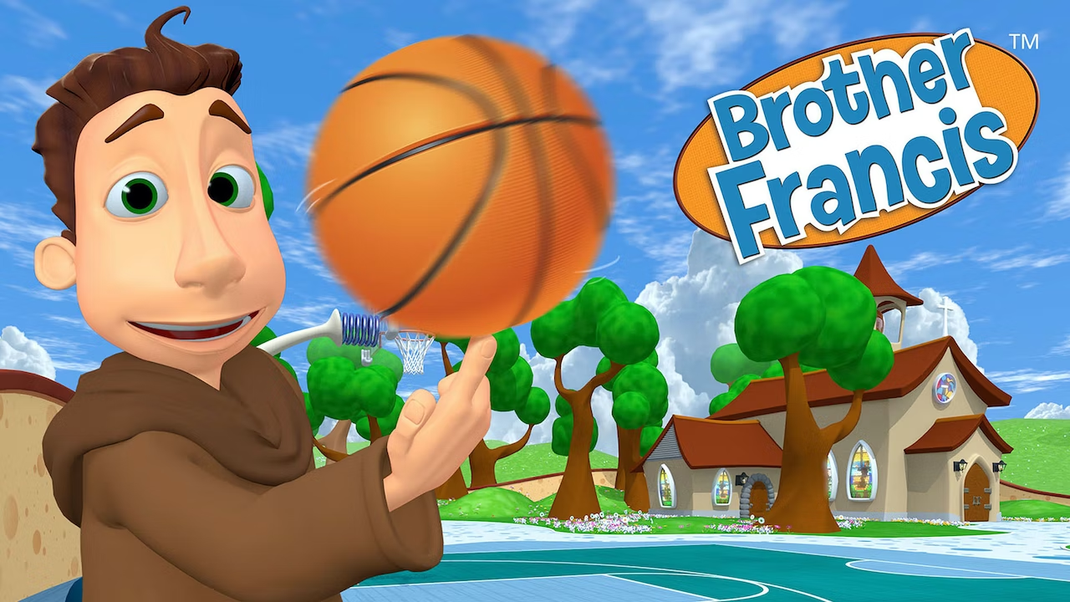Brother Francis -

Join Brother Francis as he helps children up to 8 years old understand how to live a joy-filled Catholic life.

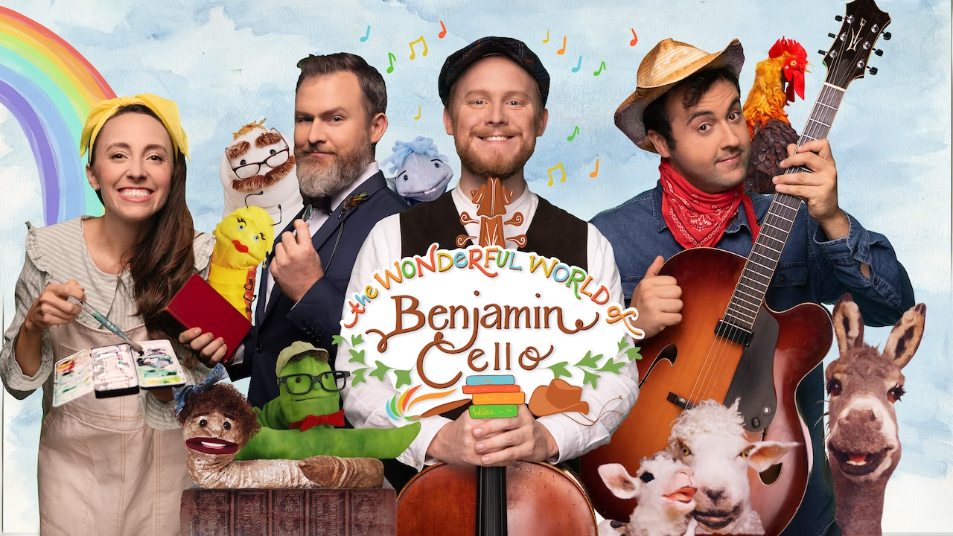Benjamin Cello-

Follow Benjamin Cello, a winsome country gentleman, as he leads his friends on song-filled adventures through the Land of the Baptized Imagination. Whether it’s dancing in the art-full beauty of Pennywhistle Park, hearing the hallelujah hoedowns of the Big Ol’ Barn, or reading deeply in the mysterious and elevated Book Endless Book Tower, The Wonderful World of Benjamin Cello will captivate your children with the beauty and purity of a God-breathed imagination!

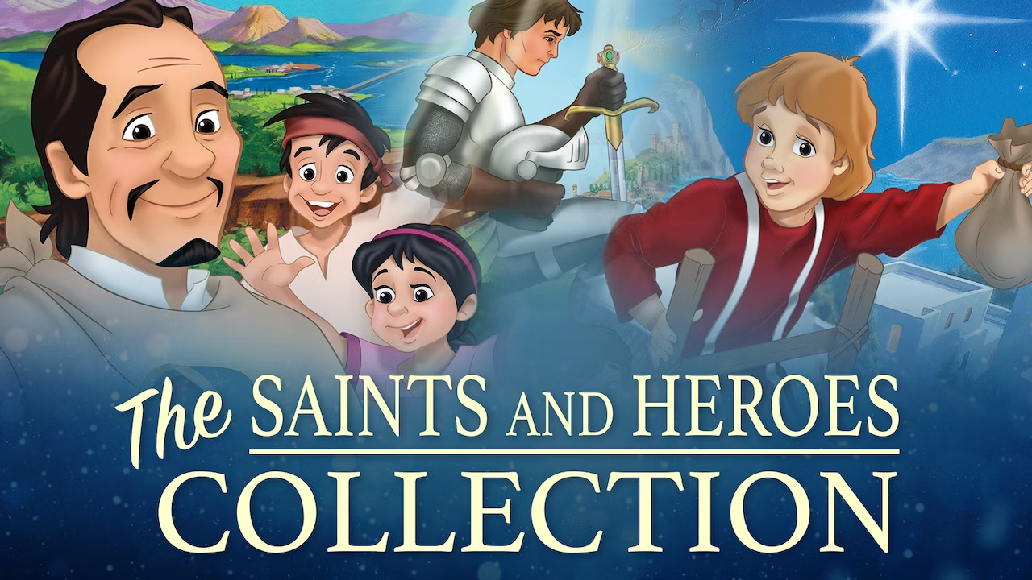Heroes of the Faith- The Stories of real-life Saints & Christian Heroes all come to life in CCC of America's award-winning animated film series. Featuring authentic role models today's child can truly believe in.

*For Adults*

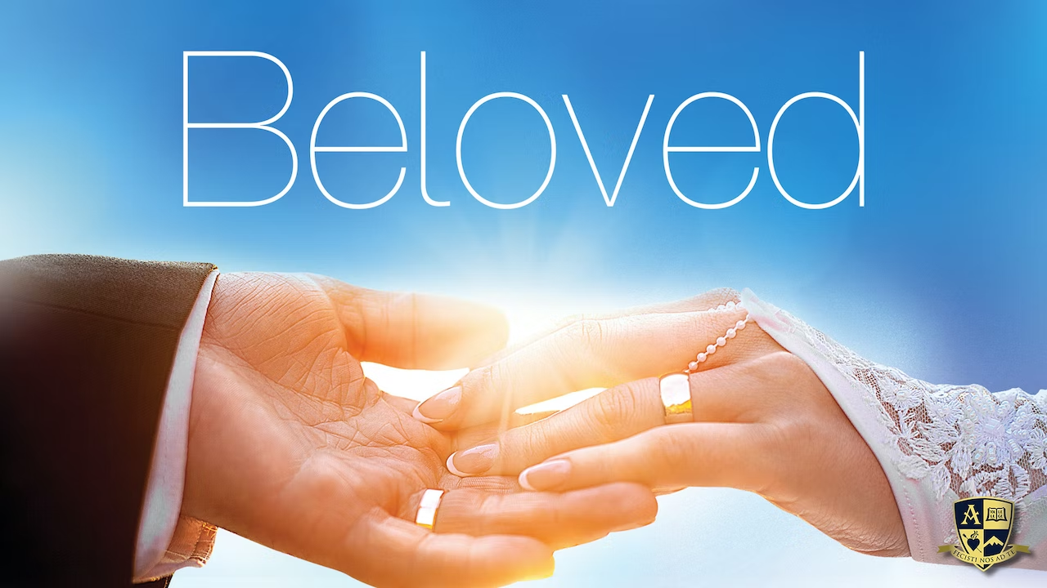 In 12 stunning sessions, BELOVED uncovers the mystery and the meaning of the sacrament of marriage. What if marriage is more than you think it is? What if God has woven into the very fabric of your humanity a purposeful need and desire that can only be fulfilled in your marriage? BELOVED invites all couples to experience firsthand the wonder, mystery, and joy behind that first "I do" ... whether you said it last year or many years ago.

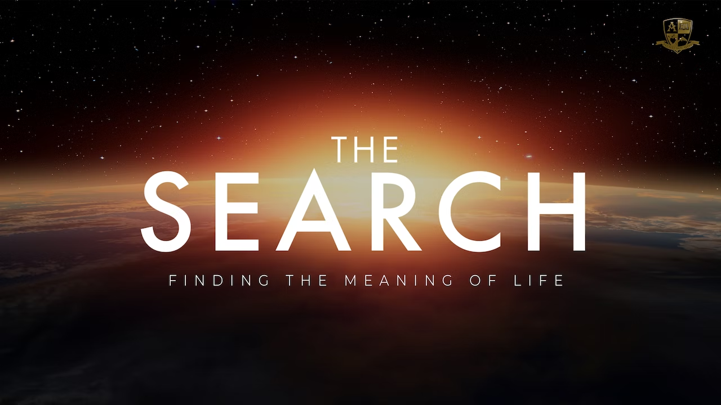

The Search-

What is this journey in between the event we call “birth” and the one we call “death”? Is the journey taking you somewhere, or are you leading yourself to some kind of destination – a destination that could extend beyond your last breath? What do you want from your life during the in between? The questions are there. And, the answers are too.